# 

# MEET Y1 - Day 2 - Lab Part 1

## Intro to Data Types

In this lab, you will learn about different data types, including **int**, **float**, **str**, and **bool**, and how to use **type()** to determine what data type something is using **Python** in **IDLE3**.

**Follow these instructions:**

1. Fill in column 2 of the table on the next page by writing what you would expect the output from **Python** to be. If you don’t think Python can do something, write error. The first row is filled out as an example.

|  |  |  |
| --- | --- | --- |
| **Expression** | **Your Guess** | **IDLE3 Output** |
| >>> type(259+33) | integer | int |
| >>> type(259-33.0) | float | float |
| >>> type(4) | int | int |
| >>> type(‘4’) | str | str |
| >>> type(‘four’) | str | str |
| >>> type(5/2.0) | float | float |
| >>> type(12 > 2*5) | bool | bool |
| >>> type(color+3) | error | error |
| >>> type(‘color’*4) | str | str |

2. Open a **Linux** terminal by double clicking on this icon: 

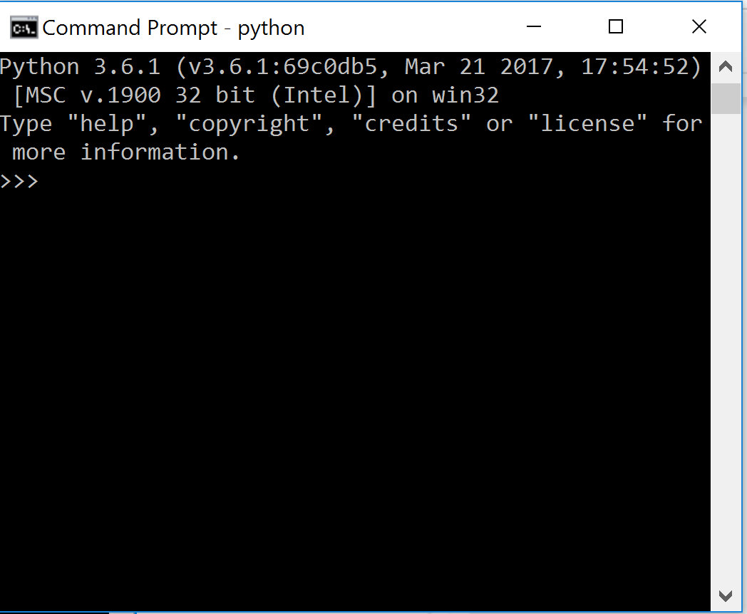

3. Type idle3 & to open **IDLE3**. A window should pop up.

4. Type each row into **IDLE3** and write what the output is in column 3. Does it match what you thought the output would be?

idleiii

5. BONUS

Think about why you got the errors you did. Test your guesses in Python!

Now back to lecture!

# MEET Y1 - Day 2 - Lab Part 2

## Variables and Errors

In this lab, you will learn how to assign values to variables, how to change the values of a variable, and how to recognize errors in code.

**Follow these instructions:**

0. Open a **Linux** terminal by double clicking on this icon: 

1. Cd into the correct folder and type startlab. Enter your username and module ***2***!

2. Type idle3 & to open **IDLE3**. A window should pop up like last time.

3. Define two variables, a = 5 and b = 10. We want to switch the values of a and b so a = 10 and b = 5.

c

4. Type the following to try to switch a and b:

>>> a = b

>>> b = a

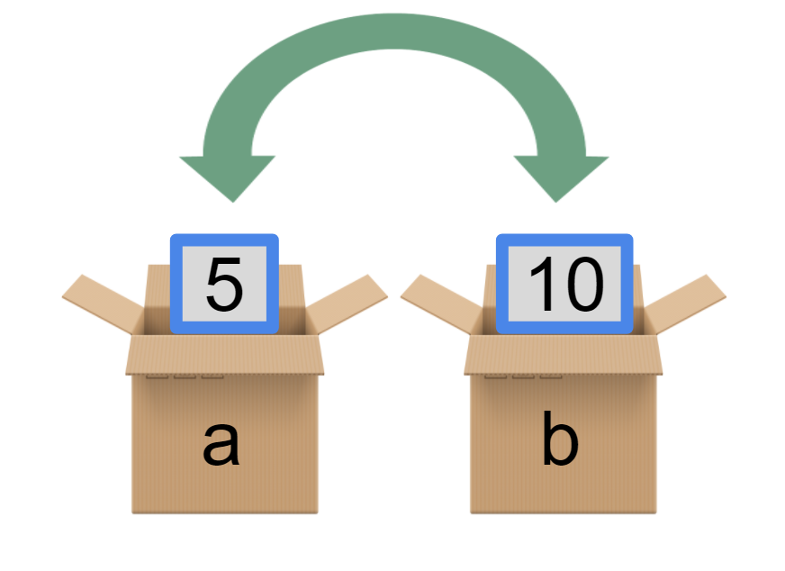

5. What are the new values of a and b? Find out by typing a and pressing the Enter key.

>>> a

_____

>>> b

_____

6. What happened? Type the following:

>>> a = 5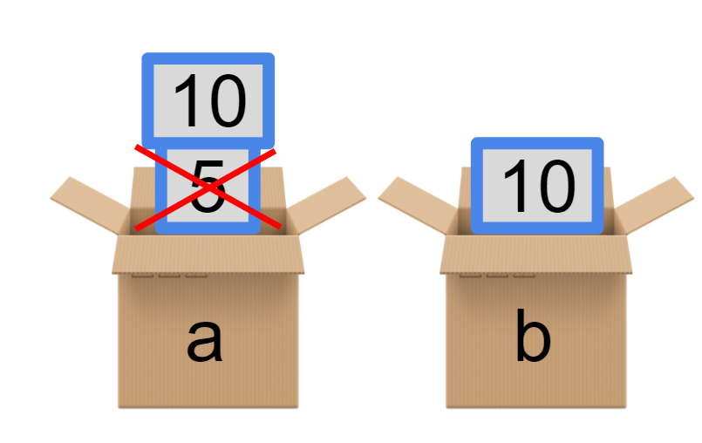

>>> b = 10

>>> a = b

>>> a

______

>>> b

______

When we set a = b, it is like we took the 10 out of the b box and put it over the 5. Then, when we did b = a, a was already 10.

7. Now let’s add a third box called c.



8. Let’s use c to hold the value of a. Type c = a.



9. Now let a be equal to the value of b. Type a = b.

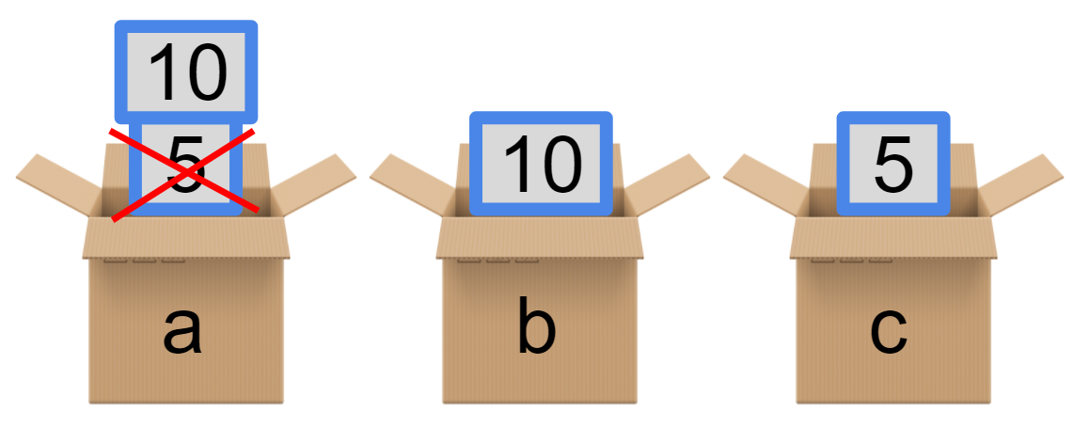

10. Finally, let b be equal to the value of c by typing b = c.

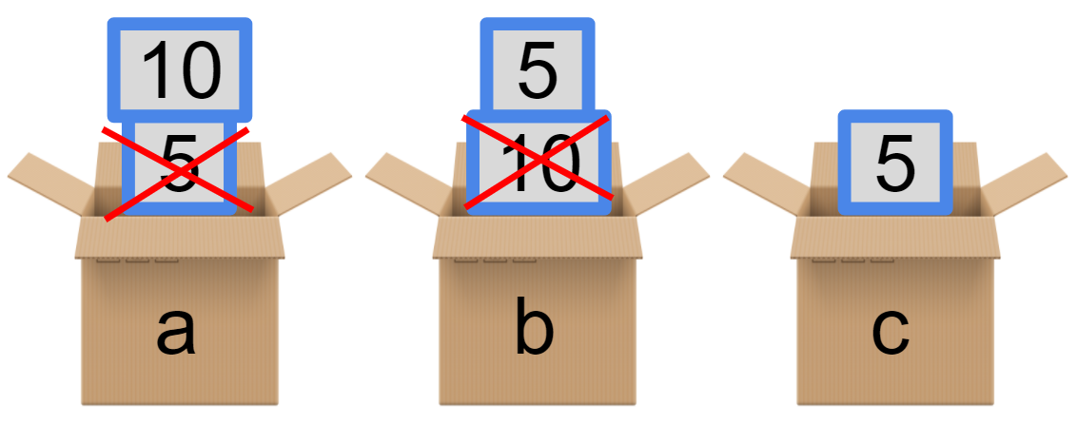

11. You did it! Find the values of a and b.

>>> a

______

>>> b

______

## 12. Strings

Now set a variable named four equal to the string 4.

>>> four = ‘4’

13. What happens when you type print(four*3)?

Its going to print fours value 3 times_________

Why did this happen?

14. Now set a variable called five equal to the integer 4.

>>> five = 4

>>> print(five)

__4______

>>> print(five*3)

__444______

15. Talk with the person next to you to figure out why print(five*3) did not output 15.

## 16. Errors

Read the intention of each program. Type the bad code into **IDLE3** to see what the bad code output is. Then write how the correct code in the fourth box. The first table is filled out as an example.

17.

|  |  |
| --- | --- |
| Intention | Print out “My name is student” |
| Bad Code | >>> my_name = ‘student’  >>> print(“My name is ’ + ‘my_name”) |
| Bad Code Output | My name is ’ + ‘my_name |
| Correct code | >>> print(“My name is ” + my_name) |

18.

|  |  |
| --- | --- |
| Intention | Print out “Hi, student” |
| Bad Code | >>> my_name = ‘student’  >>> print(“Hi,” + myName’) |
| Bad Code Output | error |
| Correct code | print (“hi, ”+ my_name) |

19.

|  |  |
| --- | --- |
| Intention | Print out “I am 15 years old” |
| Bad Code | >>> my_age = 15  >>> print(‘I am ‘ + my_age + ‘years old’) |
| Bad Code Output | error |
| Correct code | My_age = “15”  print(‘I am ‘ + my_age + ‘years old’) |

20.

|  |  |
| --- | --- |
| Intention | Print out “I am 15 years old” |
| Bad Code | >>> my_age = 15  >>> print(‘I am ‘ + my_age + ‘years old’) |
| Bad Code Output | error |
| Correct code | My_age = “15”  print(‘I am ‘ + my_age + ‘years old’) |

21.

|  |  |
| --- | --- |
| Intention | Print out the total score |
| Bad Code | >>> score = 1  >>> total = score + (count * 2)  >>> print(total) |
| Bad Code Output | error |
| Correct code | Score = 1  count = 2  total = score + (count * 2)  print(total) |

**When you are done, don’t forget to type** endlab **to finish!**

**Today’s survey:** [**https://goo.gl/forms/SRVe91TbsOYyNppW2**](https://goo.gl/forms/SRVe91TbsOYyNppW2)